$$\frac{∂η}{∂t}=f\left(η\right)+∇^{2}η$$

$$F\left(\frac{∂η}{∂t}=f\left(η\right)+∇^{2}η\right)$$

$$\tilde{\frac{∂η}{∂t}}=\tilde{f}-ξ^{2}\tilde{η}$$

First Order Time

$$\tilde{η}\left(t+Δt\right)=\left(\tilde{f}\left(t\right)-ξ^{2}\tilde{η}\left(t\right)\right)Δt+\tilde{η}\left(t\right)$$

$$\tilde{η}\left(t+Δt\right)=\left(\tilde{f}\left(t\right)-ξ^{2}\tilde{η}\left(t+Δt\right)\right)Δt+\tilde{η}\left(t\right)$$

Highlighted part!! Explicit 🡪 Implicit. Semi-implicit scheme!!

$$\tilde{η}\left(t+Δt\right)=\tilde{f}Δt-Δtξ^{2}\tilde{η}\left(t+Δt\right)+\tilde{η}\left(t\right)$$

$$\left(1+Δtξ^{2}\right)\tilde{η}\left(t+Δt\right)=\tilde{f}Δt+\tilde{η}\left(t\right)$$

Second-order Adams-Bashforth for explicit non-linear term + Second-order backward difference for $\tilde{\frac{∂η}{∂t}}$

$$\tilde{\frac{∂η}{∂t}}=\tilde{f}-ξ^{2}\tilde{η}$$

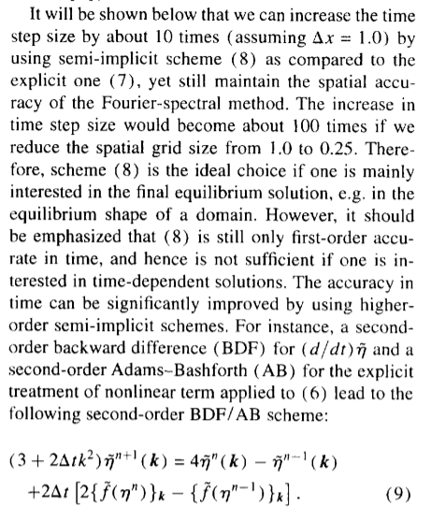

$$\left(3+2Δtξ^{2}\right)\tilde{η}\left(t+2Δt\right)=4\tilde{η}\left(t+Δt\right)-\tilde{η}\left(t\right)+2Δt\left[2\tilde{f}\left(t+Δt\right)-\tilde{f}\left(t\right)\right]$$

**Backward Difference—implicit**

$$y^{'}=f\left(t,y\right)$$

$$y\left(t+Δt\right)-y\left(t\right)=Δtf\left(t+Δt,y\left(t+Δt\right)\right)$$

$$y\left(t+2Δt\right)-\frac{4}{3}y\left(t+Δt\right)+\frac{1}{3}y\left(t\right)=\frac{2}{3}Δtf\left(t+2Δt,y\left(t+2Δt\right)\right)$$

**Adams-Bashforth—explicit**

$$y^{'}=f\left(t,y\right)$$

$$y\left(t+Δt\right)=y\left(t\right)+Δtf\left(t,y\left(t\right)\right)$$

$$y\left(t+2Δt\right)=y\left(t+Δt\right)+Δt\left[\frac{3}{2}f\left(t+Δt,y\left(t+Δt\right)\right)-\frac{1}{2}f\left(t,y\left(t\right)\right)\right]$$

$$y\left(t+2Δt\right)-\frac{4}{3}y\left(t+Δt\right)=\frac{2}{3}Δtf\left(t+2Δt,y\left(t+2Δt\right)\right)-\frac{1}{3}y\left(t\right)$$

$$y\left(t+2Δt\right)-y\left(t+Δt\right)=Δt\left[\frac{3}{2}f\left(t+Δt,y\left(t+Δt\right)\right)-\frac{1}{2}f\left(t,y\left(t\right)\right)\right]$$

$$\tilde{\frac{∂η}{∂t}}=-ξ^{2}\tilde{η}+\tilde{f}$$

$$\frac{3\tilde{η}\left(t+2Δt\right)-4\tilde{η}\left(t+Δt\right)+\tilde{η}\left(t\right)}{2Δt}=-ξ^{2}\tilde{η}\left(t+2Δt\right)+\frac{3}{2}\tilde{f}\left(t+Δt\right)-\frac{1}{2}\tilde{f}\left(t\right)$$

$$3\tilde{η}\left(t+2Δt\right)-4\tilde{η}\left(t+Δt\right)+\tilde{η}\left(t\right)=Δt\left[3\tilde{f}\left(t+Δt\right)-\tilde{f}\left(t\right)\right]-2Δtξ^{2}\tilde{η}\left(t+2Δt\right)$$

$$\left(3+2Δtξ^{2}\right)\tilde{η}\left(t+2Δt\right)=4\tilde{η}\left(t+Δt\right)+\tilde{η}\left(t\right)+Δt\left[3\tilde{f}\left(t+Δt\right)-\tilde{f}\left(t\right)\right]$$

$$\tilde{\frac{∂η}{∂t}}=-ξ^{2}\tilde{η}+\tilde{f}$$

$$\frac{-\frac{1}{3}\tilde{η}\left(t\right)+\frac{3}{2}\tilde{η}\left(t+Δt\right)-3\tilde{η}\left(t+2Δt\right)+\frac{11}{6}\tilde{η}\left(t+3Δt\right)}{Δt}=-ξ^{2}\tilde{η}\left(t+2Δt\right)+\left[\frac{23}{12}\tilde{f}\left(t+2Δt\right)-\frac{4}{3}\tilde{f}\left(t+Δt\right)+\frac{5}{12}\tilde{f}\left(t\right)\right]$$

$$-\frac{1}{3}\tilde{η}\left(t\right)+\frac{3}{2}\tilde{η}\left(t+Δt\right)-3\tilde{η}\left(t+2Δt\right)+\frac{11}{6}\tilde{η}\left(t+3Δt\right)=-Δtξ^{2}\tilde{η}\left(t+2Δt\right)+Δt\left[\frac{23}{12}\tilde{f}\left(t+2Δt\right)-\frac{4}{3}\tilde{f}\left(t+Δt\right)+\frac{5}{12}\tilde{f}\left(t\right)\right]$$

$$-2\tilde{η}\left(t\right)+9\tilde{η}\left(t+Δt\right)-18\tilde{η}\left(t+2Δt\right)+11\tilde{η}\left(t+3Δt\right)=-6Δtξ^{2}\tilde{η}\left(t+2Δt\right)+6Δt\left[\frac{23}{12}\tilde{f}\left(t+2Δt\right)-\frac{4}{3}\tilde{f}\left(t+Δt\right)+\frac{5}{12}\tilde{f}\left(t\right)\right]$$

$$11\tilde{η}\left(t+3Δt\right)+6Δtξ^{2}\tilde{η}\left(t+2Δt\right)=18\tilde{η}\left(t+2Δt\right)-9\tilde{η}\left(t+Δt\right)+2\tilde{η}\left(t\right)+6Δt\left[\frac{23}{12}\tilde{f}\left(t+2Δt\right)-\frac{4}{3}\tilde{f}\left(t+Δt\right)+\frac{5}{12}\tilde{f}\left(t\right)\right]$$